|  |  |
| --- | --- |
| **Topic** | Oracle SQL Language Fundamentals I |
| **Document Name** | SQL03-EX-01-05 |
|  |  |

## Exercise SQL03-EX-01:

**Definiton :** Write followig SQL queries:

* Add a colum to employees table named MAX_SALARY.
* Update MAX_SALARY with maximum salary amount with subquery.
* Delete employee who have minimum salary using subquery.

**SQL:**

ALTER TABLE hr.employees

ADD max_salary number(10);

UPDATE hr.employees

SET max_salary = (SELECT max(salary)

FROM hr.employees);

DELETE from hr.employees

WHERE salary = (select min(salary) from hr.employees);

**Screenshot:**





## Exercise SQL03-EX-02:

**Definiton :** Write followig SQL queries:

* Define index (named DPR_NAME_IDX) on DEPARTMENT_NAME column of DEPARTMENTS table.
* Define constraint (named CNSTR_SALARY) on employee salary. (Salary must be between 1000$ and 100.000$)
* Drop defined index.
* Enable, disable, drop defined constraint.

**SQL:**

CREATE INDEX DPR_NAME_IDX

ON hr.departments(DEPARTMENT_NAME);

alter table hr.employees

add constraint CNSTR_SALARY check (salary >= 1000 and salary <= 100000);

DROP INDEX DPR_NAME_IDX;

ALTER TABLE hr.employees

DISABLE CONSTRAINT CNSTR_SALARY;

ALTER TABLE hr.employees

ENABLE CONSTRAINT CNSTR_SALARY;

ALTER TABLE hr.employees

DROP CONSTRAINT CNSTR_SALARY;

## Exercise SQL03-EX-03:

**Definiton :** Create a table from EMPLOYEES with distinct department_id column. Add department_name to that table. With DEPARTMENTS table, update department_name for included department_ids and insert department_id and department_name values for not included rows. Use MERGE keyword.

**SQL:**

CREATE TABLE temp

AS (SELECT DISTINCT department_id

FROM hr.employees);

ALTER TABLE temp

ADD department_name varchar(20);

MERGE INTO temp x

USING (SELECT department_id, department_name FROM hr.departments) y

ON (x.department_id = y.department_id)

WHEN MATCHED THEN

UPDATE SET x.department_name = y.department_name

WHEN NOT MATCHED THEN

INSERT(x.department_id, x.department_name)

VALUES(y.department_id, y.department_name);

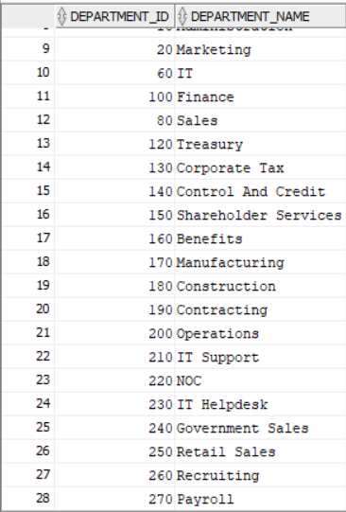**Screenshot:**

## Exercise SQL03-EX-04:

**Definiton :** Using **WITH** keyword, do following jobs:

* Firstly select first_name, last_name, job_id, department_id from employees table whoes job_id starts with ‘S’.
* Additionally select job_title and min-max salary amount.
* Add department_name to that query.
* Lastly concat first_name and last_name with space as full_name alias and list with other selected columns.

**SQL:**

WITH EmpJobStartingWithS AS (

SELECT (first_name || ' ' || last_name) as full_name, job_id, department_id

FROM hr.employees

WHERE job_id LIKE 'S%'

)

SELECT a.full_name, a.job_id, a.department_id,

m.job_title, m.min_salary, m.max_salary, x.department_name

FROM EmpJobStartingWithS a

INNER JOIN hr.jobs m ON a.job_id = m.job_id

INNER JOIN hr.departments x ON a.department_id = x.department_id

**Screenshot:**

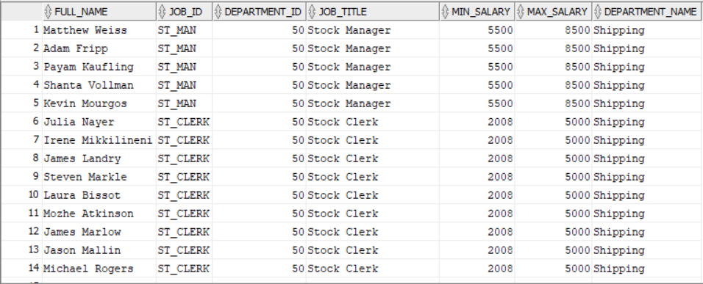

## Exercise SQL03-EX-05:

**Definiton :** Search for COMMIT and ROLLBACK keywords and explain them.

COMMIT argument pinpoints the place where it is written. When we use ROLLBACK we can get back to the last committed pinpoint.